**GEMINI MULTI MODAL**

Gemini prompt can a text and image, and that’s why it is called as multi model.

Delly is one of the model in gemini that helps to generate image output by giving the text as it’s input.

Refer GENAI\genai-basics.py for code. But it is not implemented with dell.

**NLP:**

It involves computer ability which can analyses, understand, translate text data. It is also cleaning the text data. We can do following tasks with NLP

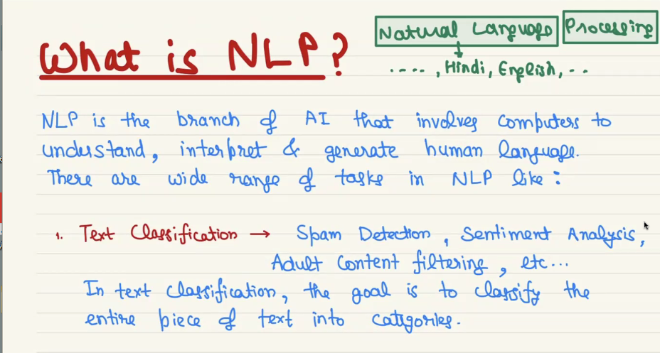

In text classification we take whole text and classify it.

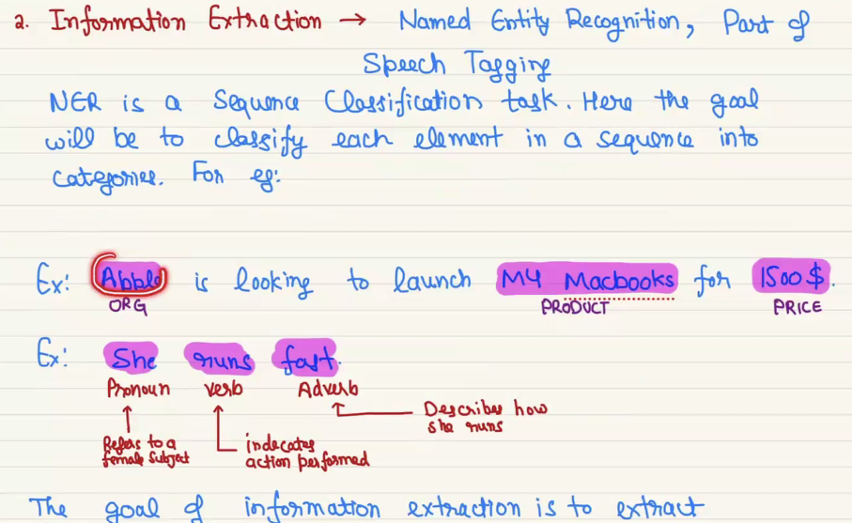

In information extraction we takes each and every word and classify that each word.

EX: In what’s app when we type a date it is instantly highlighted by using this information extraction, it take only the date part of the text and classifies it.

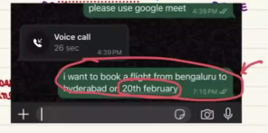

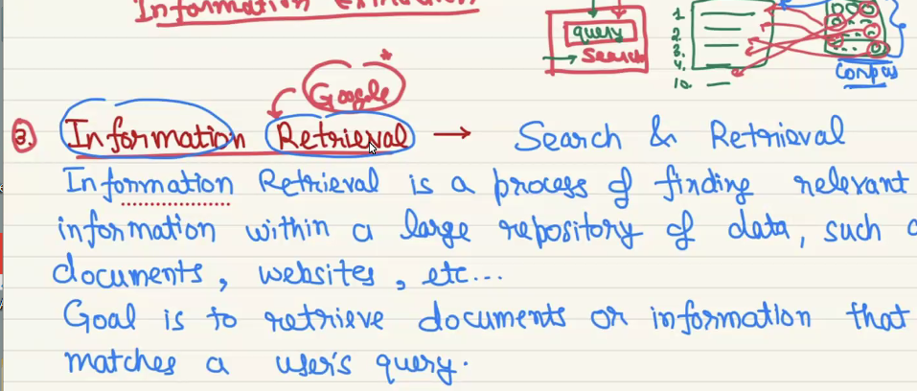

EX: we when type some text on chrome search bar the top 10 results are fetch in recommendation part.

